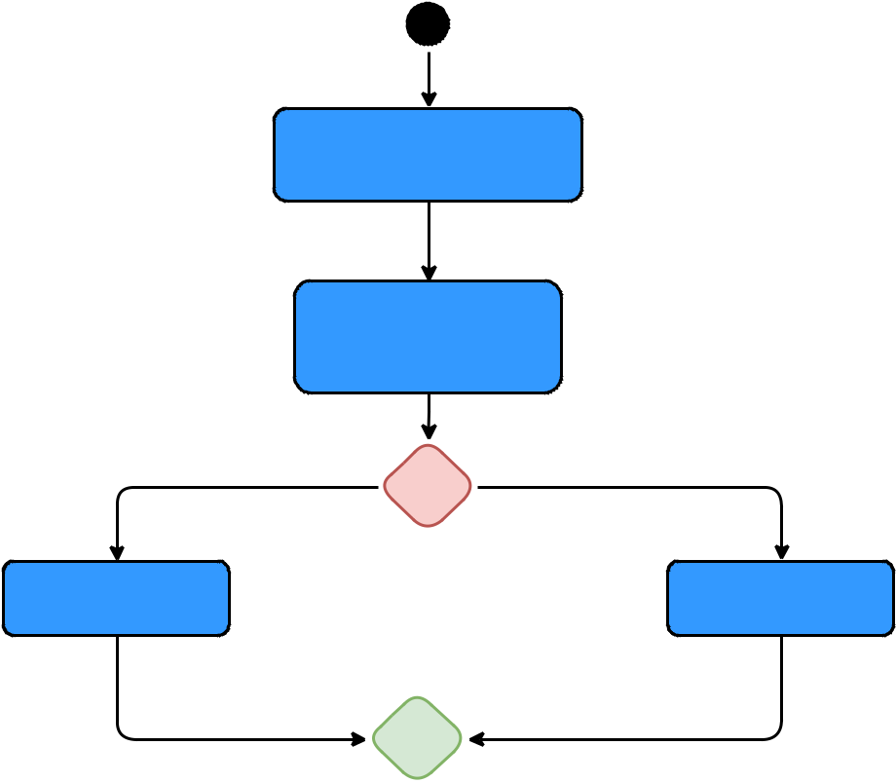**OPEN OBASEB**

**SEARCH FILE**

**[User wants basic search]** **[User wants advanced search]**

**BASIC SEARCH** **ADVANCED SEARCH**

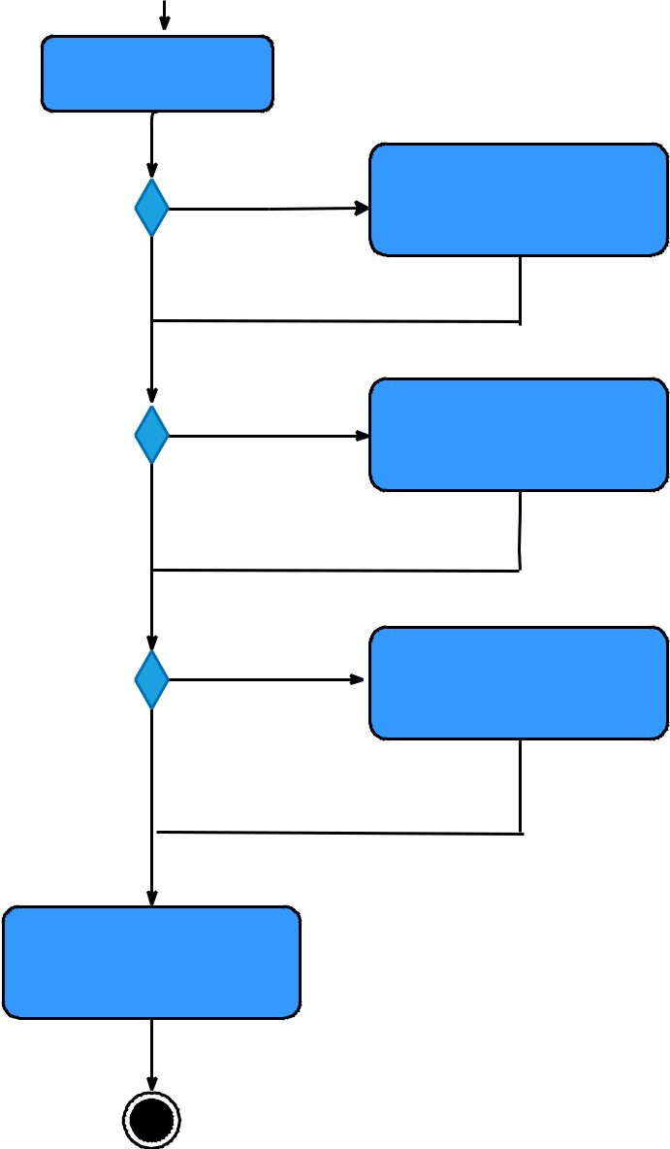

**LIST FILE**

**[If edit file]** **EDIT FILE**

**OPEN OBASEB**

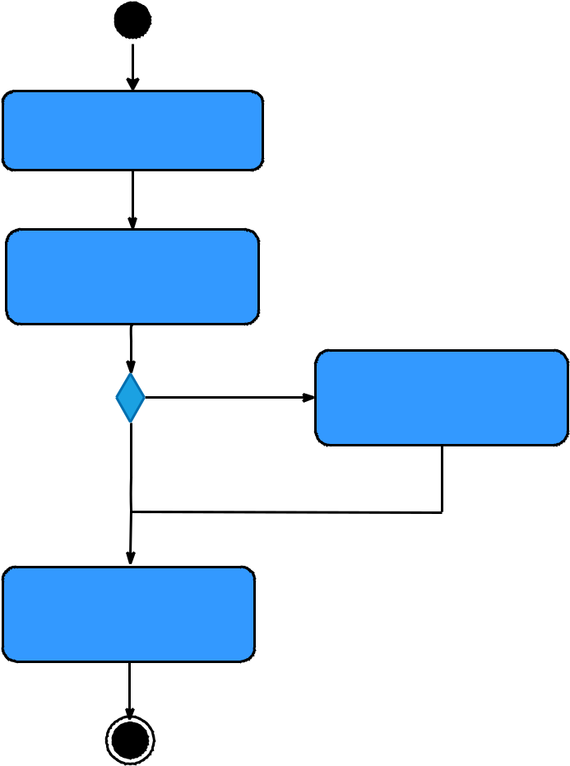

**CREATE FILE**

**[If add file]**

**[If not add file]**

**SAVE FILE**

**ADD FILE**

**[If not edit file]**

**[If add file]**

**[If not add file]**

**ADD FILE**

**[If delete file]**

**DELETE FILE**

**[If not delete file]**

**SAVE FILE**